

**How to Enable HDMI 2 on Embedded NVR (with two HDMI ports)**

1. Right Click mouse from the main "Live View" mode. Select "Main Menu" and login with your DVR account credentials (login information).

2. Under the "Setting" section (bottom row), click on "System"

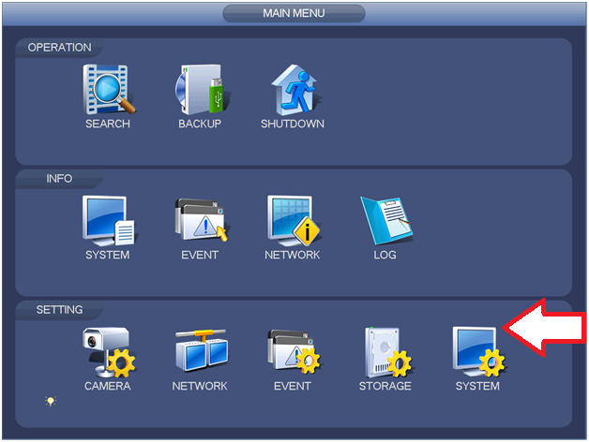

3. Click and "check" the box for Navigation Bar. Click APPLY and SAVE. Exit all the way out to Live View.

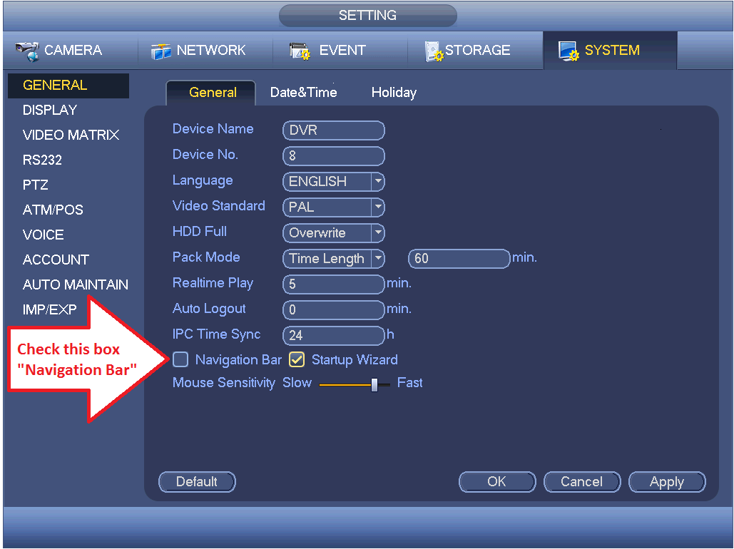

4. At "Live View" screen, click any one of the camera partition, the "Navigation bar" will appear at the bottom of the screen.

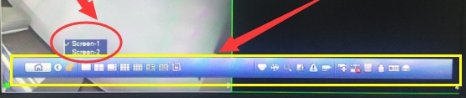

Navigation Bar

5. Connect your HDMI cables to their respective monitors. In order to configure HDMI2,

click the icon  and select Screen-2.



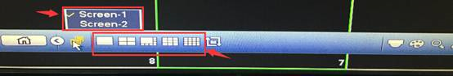

6. Select which screen partition and cameras you would like to be displayed at the HDMI2.

 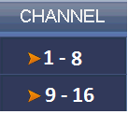

Note: You cannot customize which cameras to be displayed on the screen.

7. When you're done selecting the partition and cameras, click again the icon  and select the "Screen 1" to go back to Live View and send the configured settings for HDMI2.