**AP5GV3(a) Quick Guide**

1. Device Connection Diagram

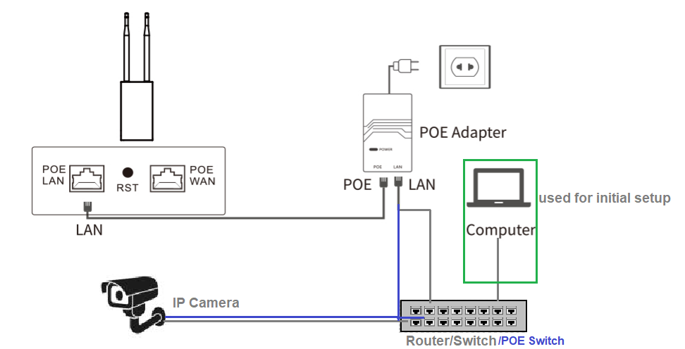

1. The device defaults to “Router Mode**”. Optiview already set the pair in Bridge mode, therefore, no configuration is needed for these access points. They are basically plug and play devices in Bridge mode. Simply plugging network devices such as IP camera or DVR, where one access point is set at AP and the other as remote station.**
2. Open a browser on a computer or mobile phone and use IP: 192.168.10.1 to enter device’s menu OSD screen. Default Login name: admin, password: admin

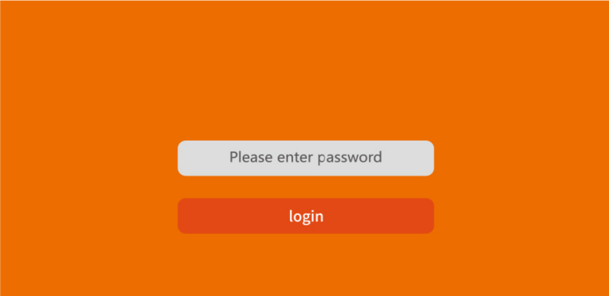

1. Select the “Wizard” to select among the four modes: AP, Bridge, Router, and Repeater mode.

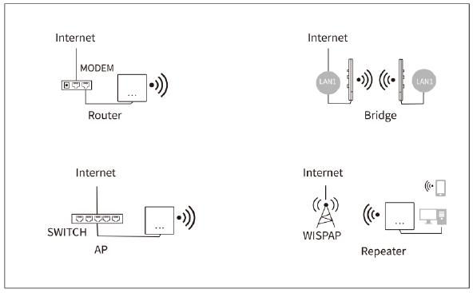

1. Setting up AP Mode.
2. Select AP Mode and set the internal IP address.
3. Set the WiFi password and security settings (PSK password).

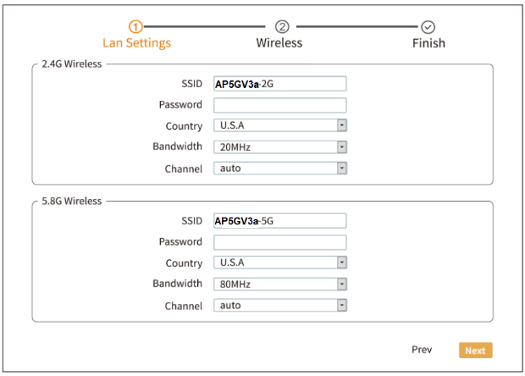

1. Bridge Mode.
2. Select Bridge mode and set the LAN IP address.

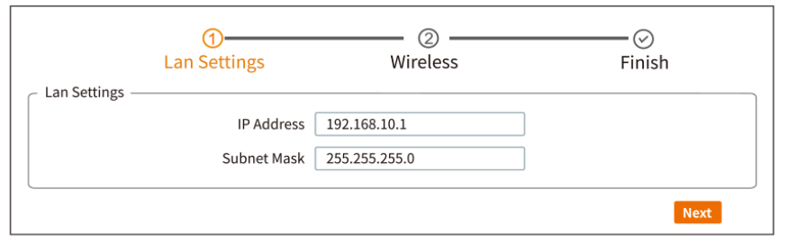

1. Select 2.4 G or 5.8G band, scan and select your wireless SSID and enter the password.

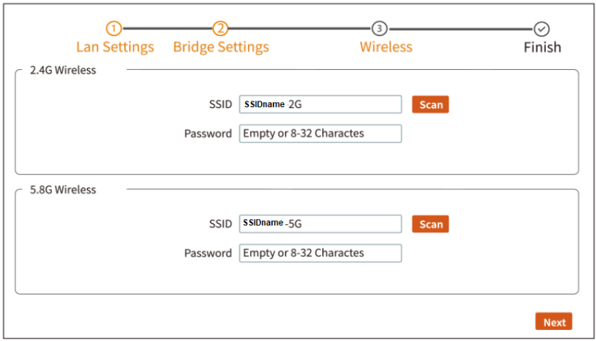

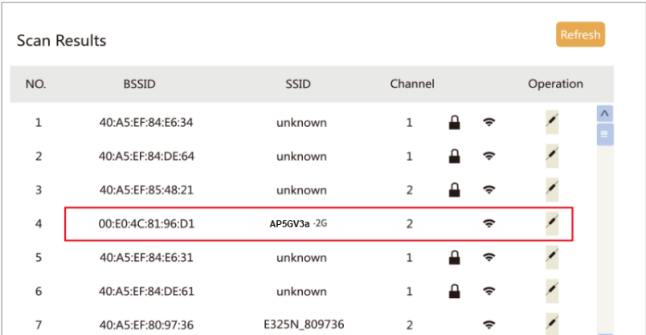

1. Router Mode

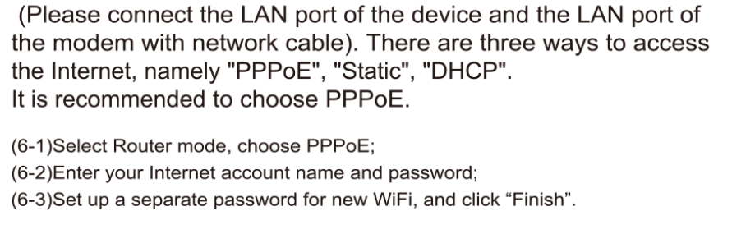

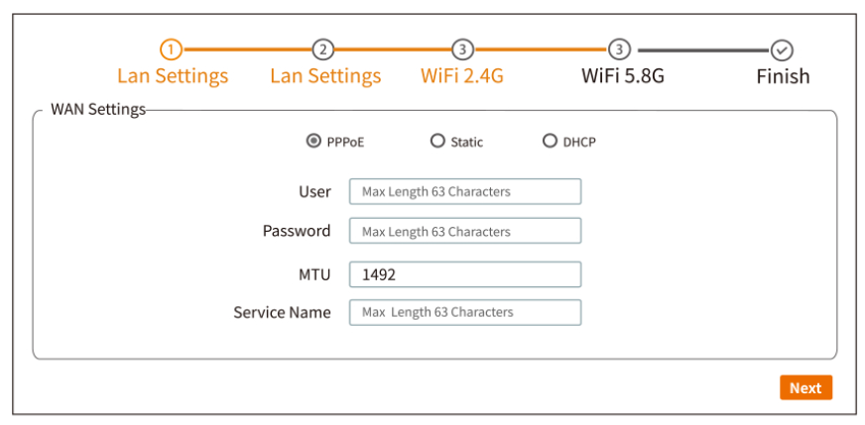

1. Repeater Mode

