Steps in Viewing Product Demo: People Counter IP Camera

- Product Demo Using Optiview VMS
- Download the Optiview VMS from our Technical Support site:
http://support.optiviewusa.com/DVR/software/VMS/2018/OptiviewVMS2018_En_Win32_Optiview_IS_V2.02.0.T.20180331.exe

Connection Profile:
http://support.optiviewusa.com/demo/IPcamera/device.zip

- After installing the software, open it by clicking + and go to Devices
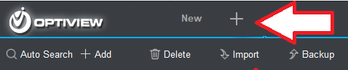

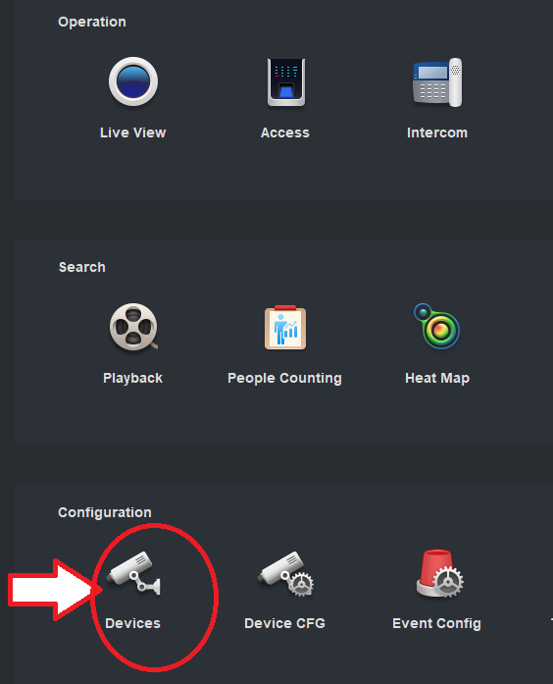

- Click “Import” as shown below to import pre-configured connection profile in order to connect the software to the Demo DVR at Optiview.
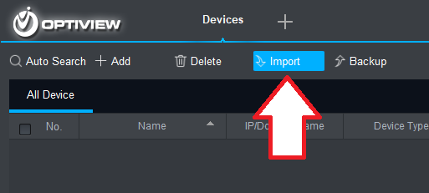

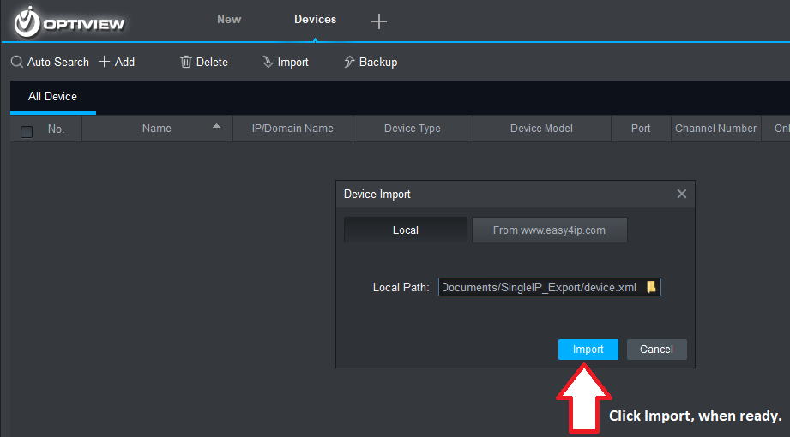

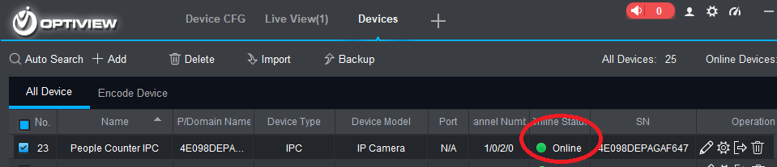

- View the LIVE Cameras by clicking the + icon then go to Live View
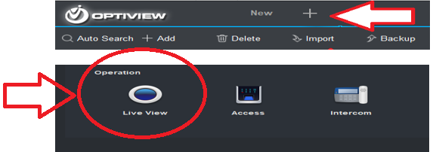

- Click the DVR icon for the DVR site connection
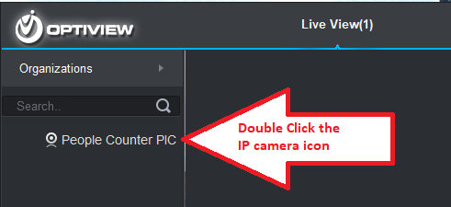

- Product Demo Using Optiview Mobile App

- Download the Optiview Mobile app on your smart phone using this link or QR Code and follow the quick instruction guides from the Manual in installing the app.

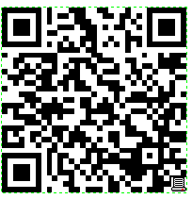
https://optiviewusa.com/mobile-applicationsdos/
- Open the app on your phone. Tap the icon on the top left corner (Menu button).
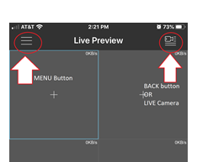

- Add the IP camera connection profile by following these steps:
- Tap “Device Manager”
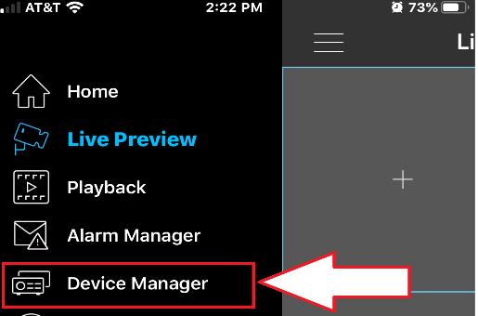

- Tap + to add an IP camera connection profile
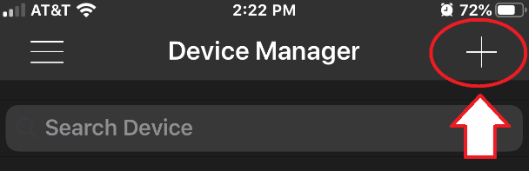

- Scan the Connection Profile QR Code for the People Counter camera by tapping the QR Code icon as shown below. You need to have the Connection QR Code ready for scanning prior to going to the next step.
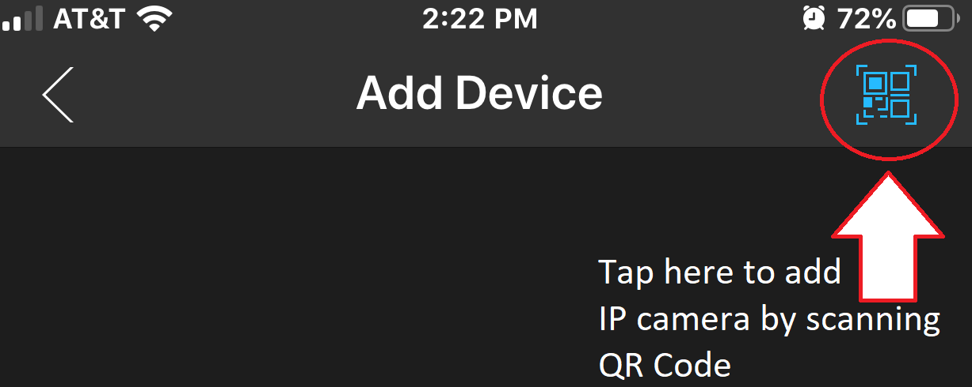

Connection Profile QR Code for People Counter IP Camera
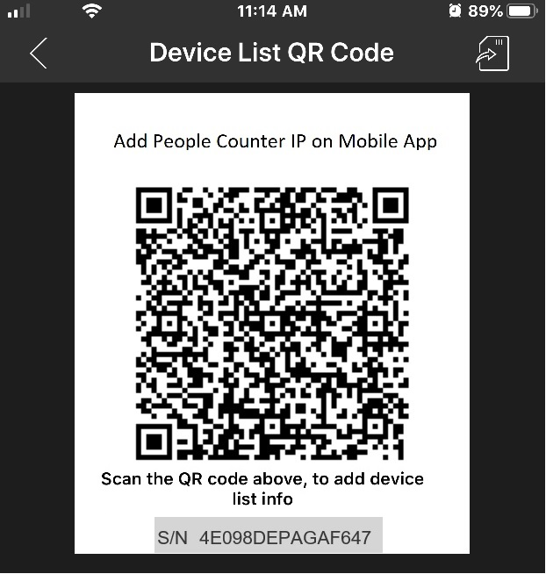

- Once the QR code above was successfully scanned, the connection profile will be listed on the Device Manager.
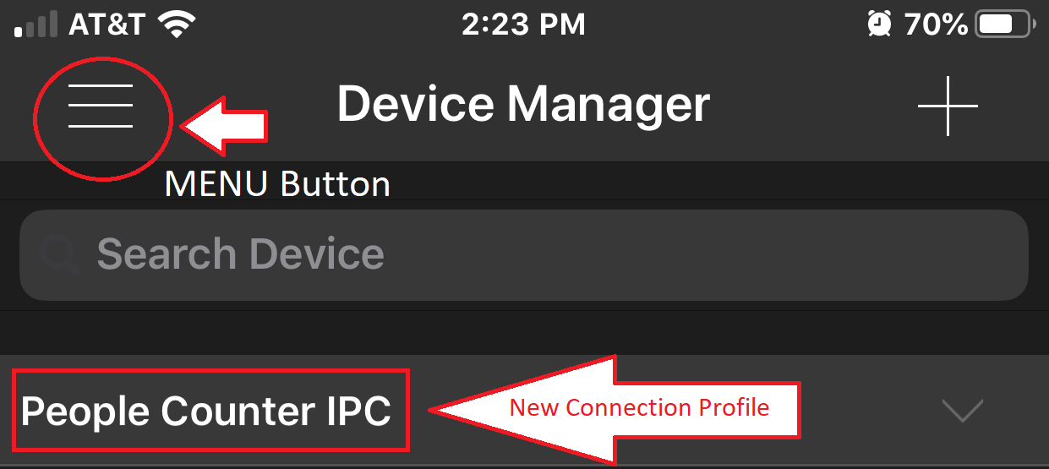

Tap the MENU button then tap “Live Preview”.
to see the “LIVE View” Mode on the app.

- Tap the camera icon (top right corner) to select the camera for Live Viewing.
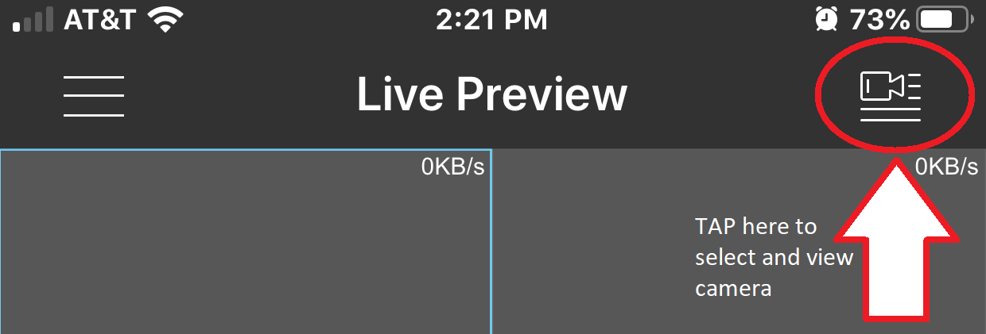

- Tap the round button line up for the camera to select it, then tap
“Start Live Preview”.
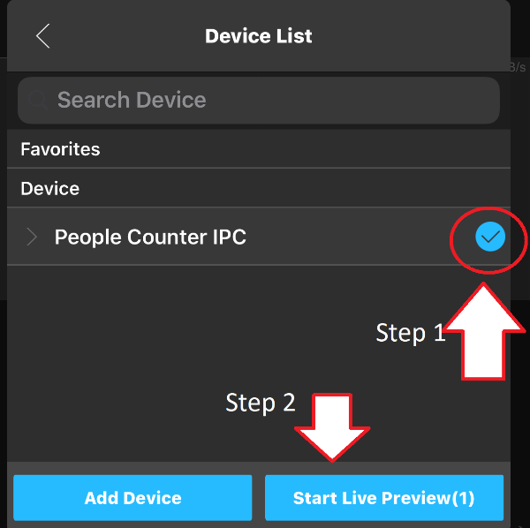

- Live View video will start as soon as you tap “Start Live Preview”
