**Password Reset Process**

Typically, an unlock pattern is the default means of accessing your DVR. If you have forgotten or need to reset the unlock pattern for your device click on the **Forgot Pattern**button.

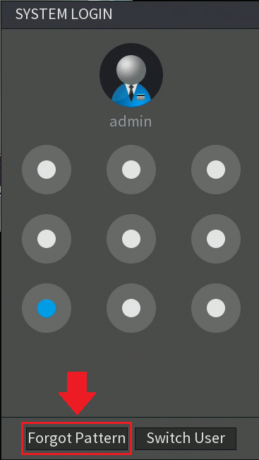

Next, in the system login screen, click on the **Forgot Password**icon (My_Great_Capture_Screenshot_2018-09-19_10-41-06.png) to access the **Reset Password**menu.

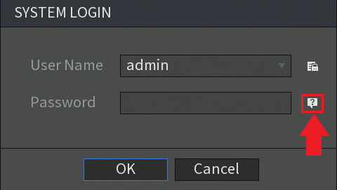

**Note:**To provide a secure password reset environment a valid email address, serial number, etc may be requested. All required information is **only** used to verify the validity of the request and a means of providing a security code to you. If you agree and would like to continue with the reset process click **OK**to continue.

There are two ways to reset your password, you can use the QR code method, or via assigned security questions that were set by you during initial setup. We will begin with the QR code method first.

**QR Code Method**

Using the QR code method to reset your password will require you to download Optiview Mobile App (Optiview VMX-M) from the Google Play or App store. Before proceeding, please download and launch the app to proceed.

1. If there is no email address yet entered to the Reset Password window, enter a password now

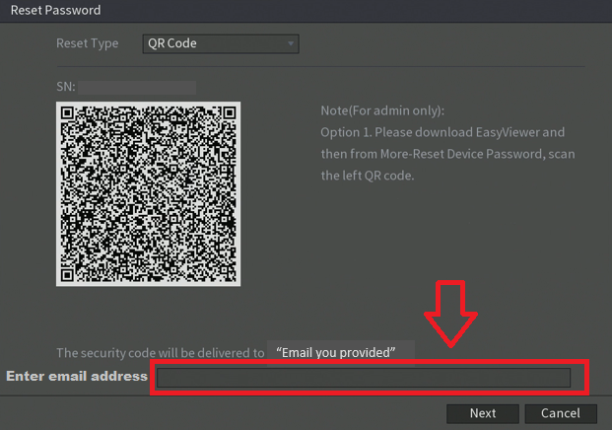

1. Once the app has been successfully downloaded, go back to the DVR and in the **Reset Password** menu, make sure QR Code is set as your reset type. This should be the first option in the drop-down menu, however, this option is also set as the default method for obtaining passwords.

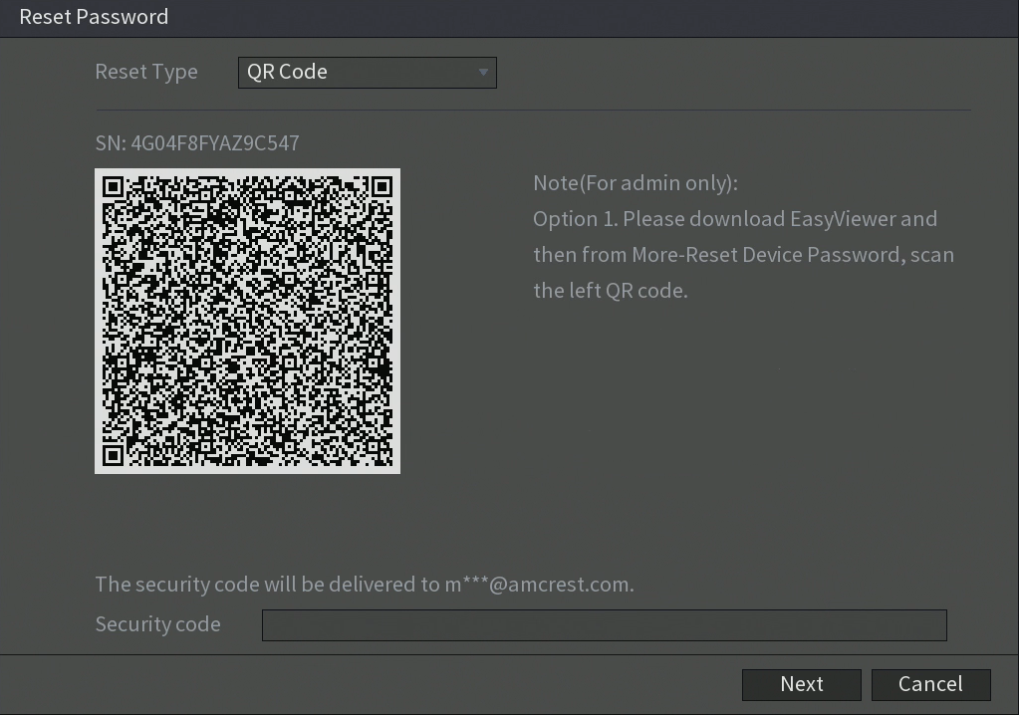

“Email you provided”

1. To begin, open the Optiview VMX-M app. In the app click on the **“Me”** button located at the bottom on the screen.

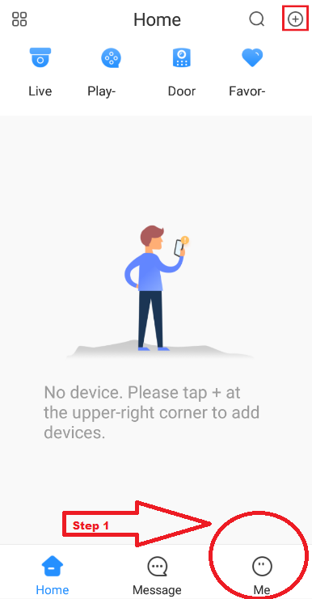

1. Tap “Password Security”, then tap “Reset Device Password”.
2. Move your phone so that the camera will be able to scan the QR code from the CCTV equipment (DVR, NVR or IP camera). The app will then request to use your mobile device's camera to read the QR Code. Click **OK**and then scan the QR code provided by the device

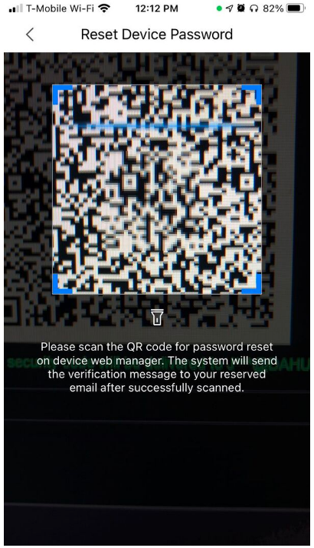

When you have successfully scanned the QR code an email will be sent to the email address associated with your device. The sender of this email will be labeled "**Password Reset**and would be sent by the following address: "**support\_gpwd@htmicrochip.com**".

1. Open the email and locate the generated security code that was sent to you. This will be the security code you will need to type into the DVR to reset your password.

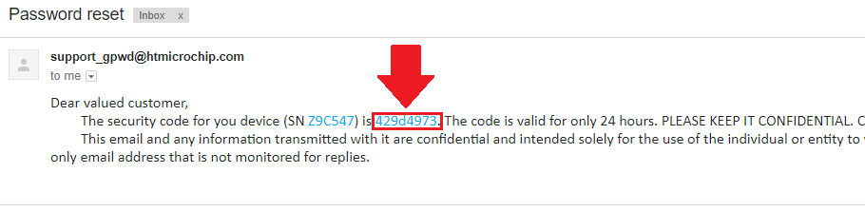

**Note:**The security code that was provided will only be valid for **24 HOURS**. If you do not use the code within 24 hours a new one will have to be generated again to complete the password reset process.

Next, enter the provided security code from your email into the **Security code**field in the **Reset Password**menu then press **Next**to continue.

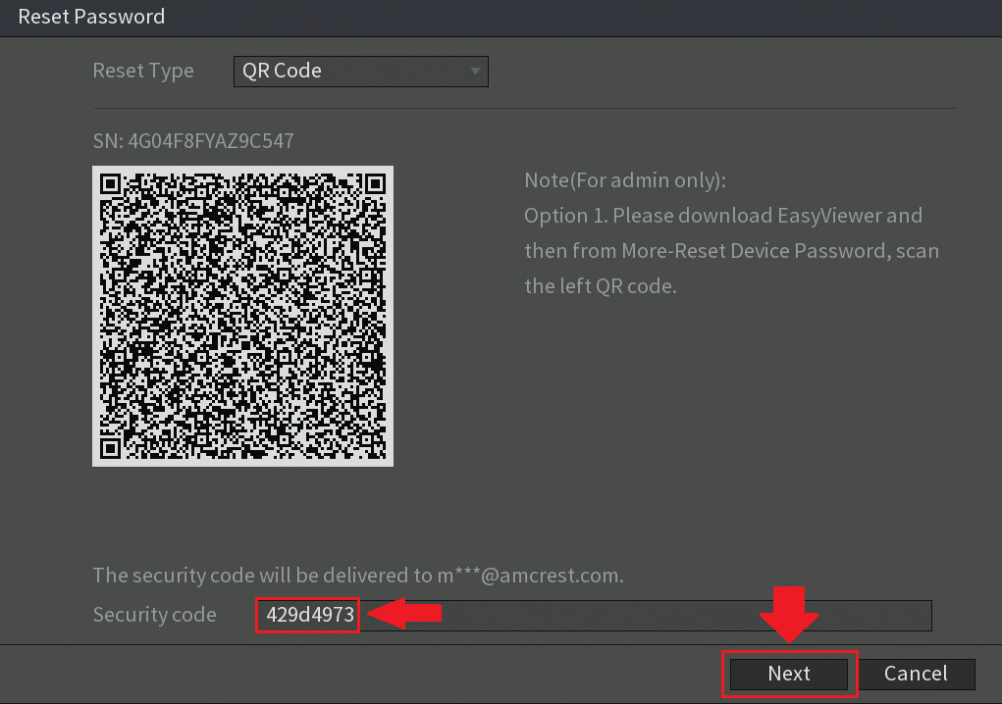

Type in the new password for your device in the **New Password**field and type it again into the **Confirm Password**field. Please note, it is recommended to use a password that has between 8 to 32 characters using a combination of letters and numbers. Please do not use special characters such as, ( ' " ; : &). When you have entered a strong enough password, click on the **Save**button to save the new password to your device.

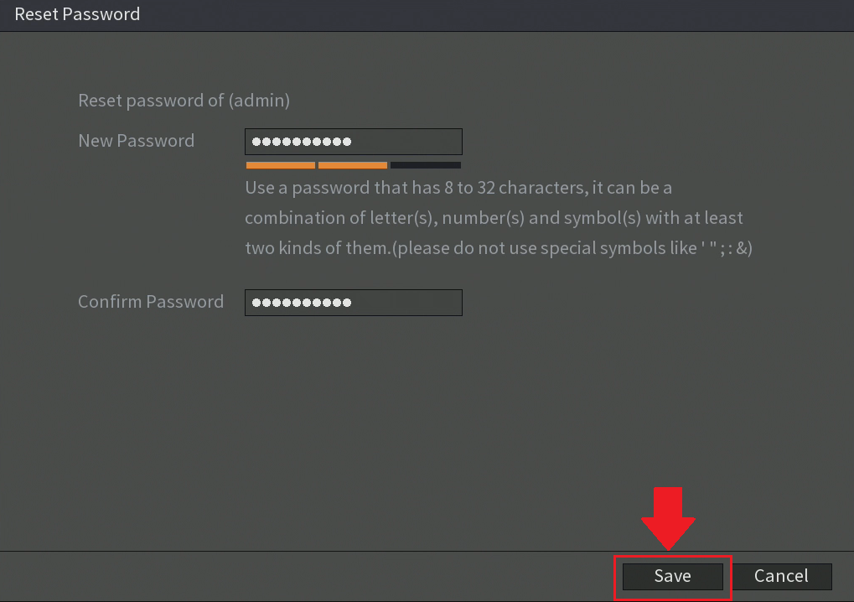

Your new password is now applied to your device, click **OK.**You will now be able to login using your new password. Enter the new password into the **System Login**screen and press **OK**to log into your system.

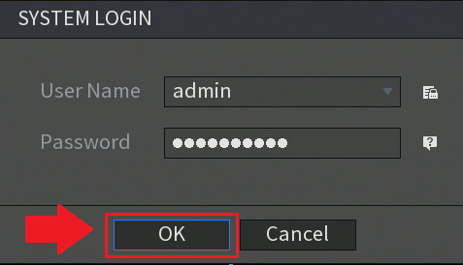

**Security Questions**

If you do not want to use the QR Code method to reset your password, you can answer the assigned security questions that were set by you during initial setup. To begin, navigate to the **System Login**menu and click on the **Forgot Password**icon (My_Great_Capture_Screenshot_2018-09-19_10-41-06.png) to access the **Reset Password**menu. From the **Reset Type**drop down menu select **Security Questions**.

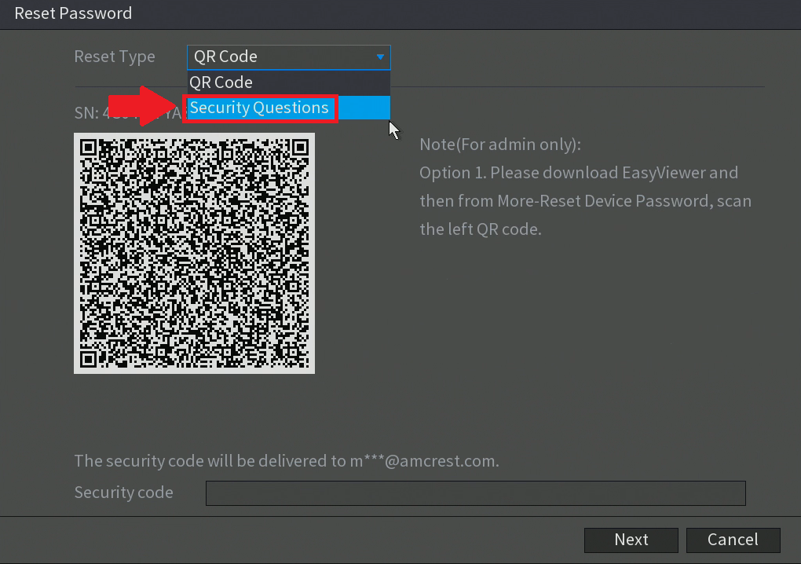

Enter the answers that you assigned for each security question and press **Next**to continue.

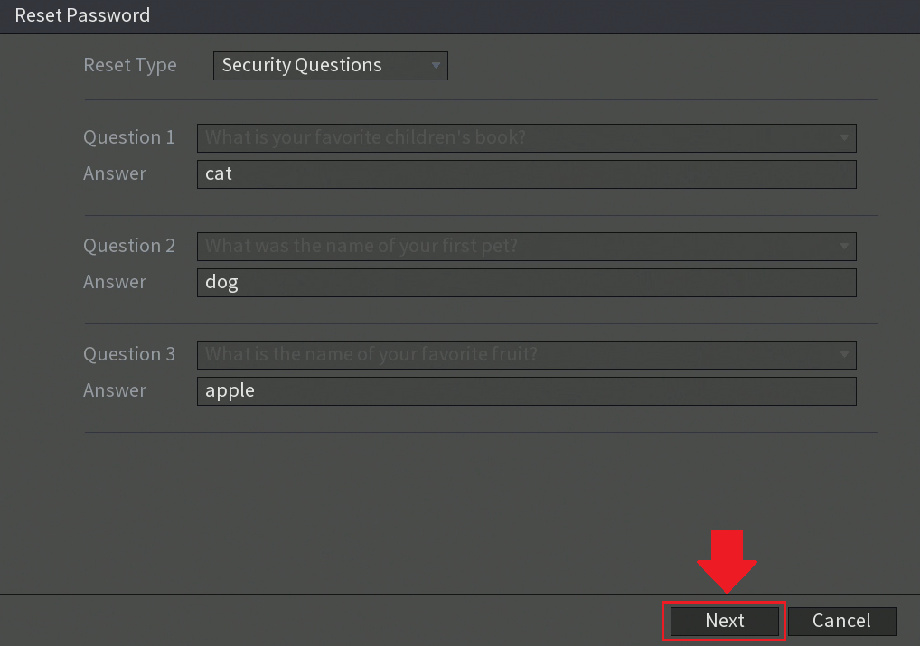

Type in the new password for your device in the **New Password**field and type it again into the **Confirm Password**field. Please note, it is recommended to use a password that has between 8 to 32 characters using a combination of letters and numbers. Please do not use special characters such as, ( ' " ; : &). When you have entered a strong enough password, click on the **Save**button to save your new password to your device.



Your new password is now applied to your device, click **OK.**You will now be able to login using your new password. Enter the new password into the **System Login**screen and press **OK**to log into your system.



You can now make the proper modifications to any security features such as unlock patterns, security questions, or any other security feature tied to your system. As a last resort option, if you are having issues resetting your password a hard factory reset of your device may be necessary.