

**Optiview VMS**

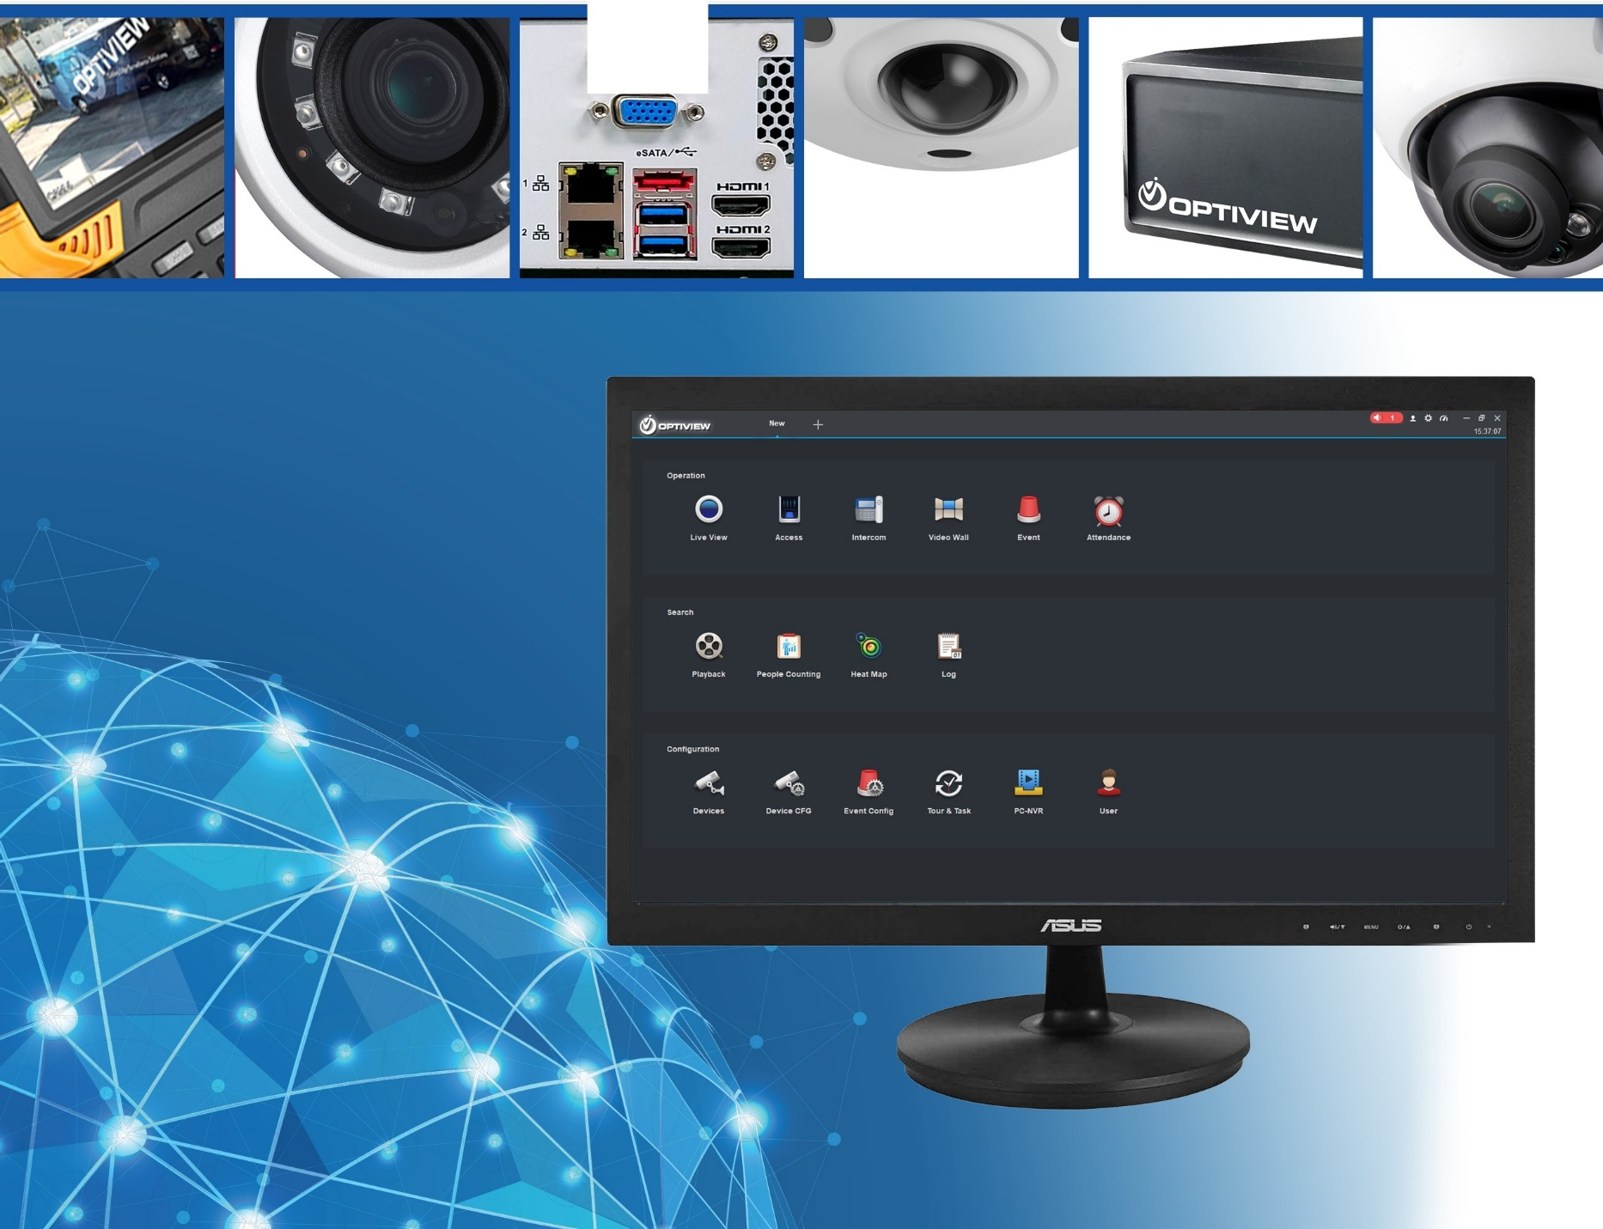

**64-bit Mac Catalina**

Quick Install Guide



1. 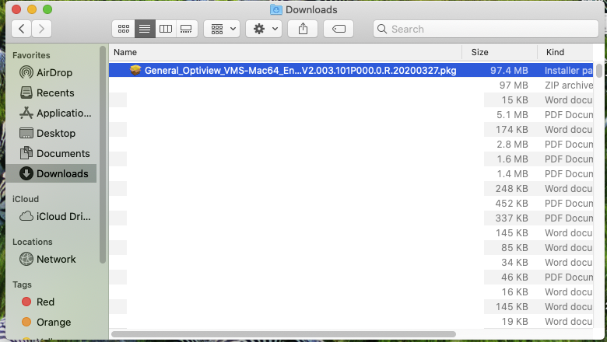DOWNLOAD OPTIVIEW VMS MAC 64
2. 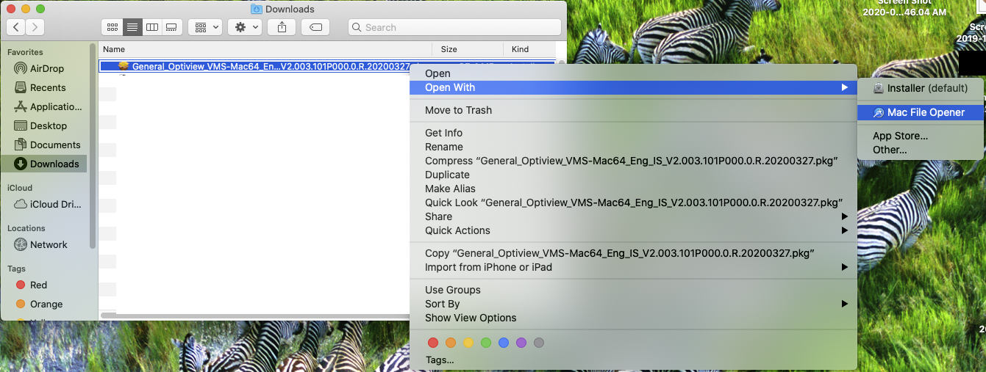**RIGHT CLICK** ON FILE, SELECT “OPEN WITH” AND THEN SELECT “MAC FILE INSTALLER”
3. 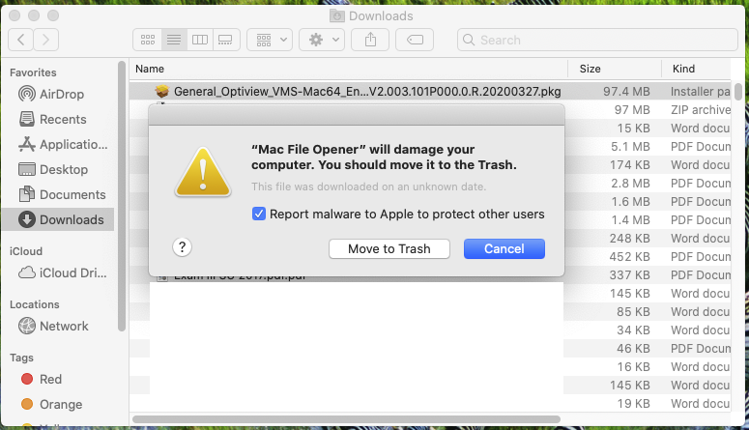CLICK CANCEL ON WARNING
4. 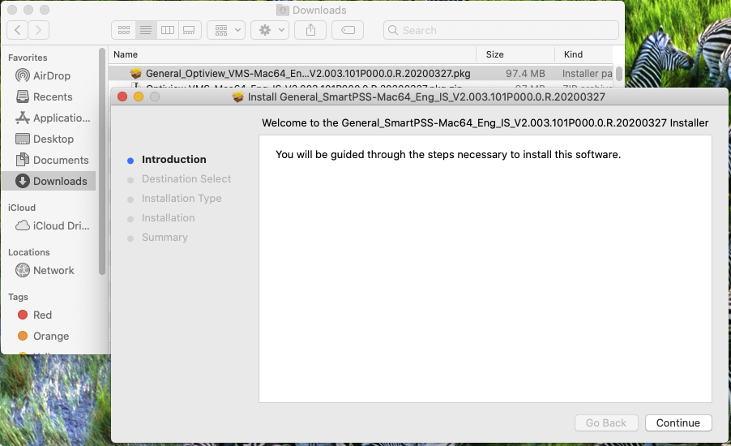DOUBLE CLICK ON INSTALL PACKAGE FILE
5. CLICK INSTALL

