How to Search/Playback Video

1. Log in to Main Menu at the DVR or NVR

Right click mouse and click “Main Menu”. Use your login credentials at System Login screen

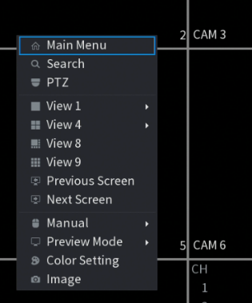 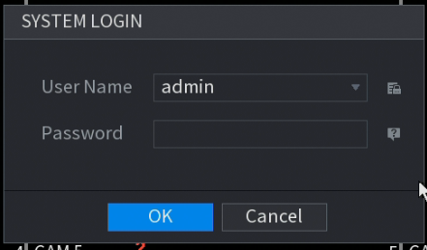

1. Select “Video” from the Main Menu to start the playback/search.

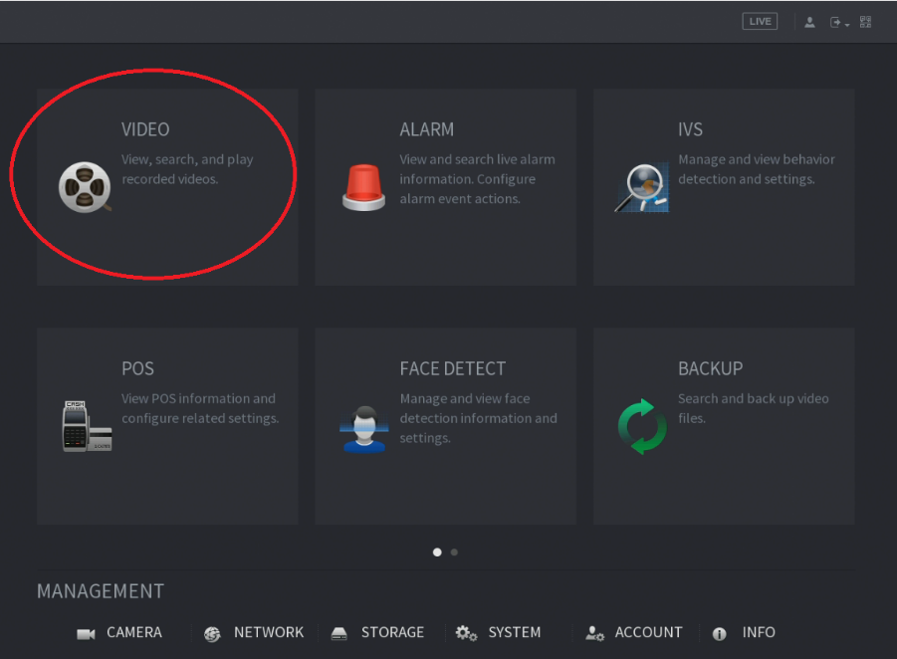

1. At the top right-hand side of the menu screen, select the month or date to search video. Any dates with white round button below the date indicates there is an available video, otherwise it means no video available for the selected date. Press left/right or down arrow to select month.

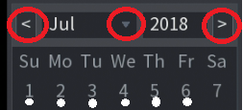

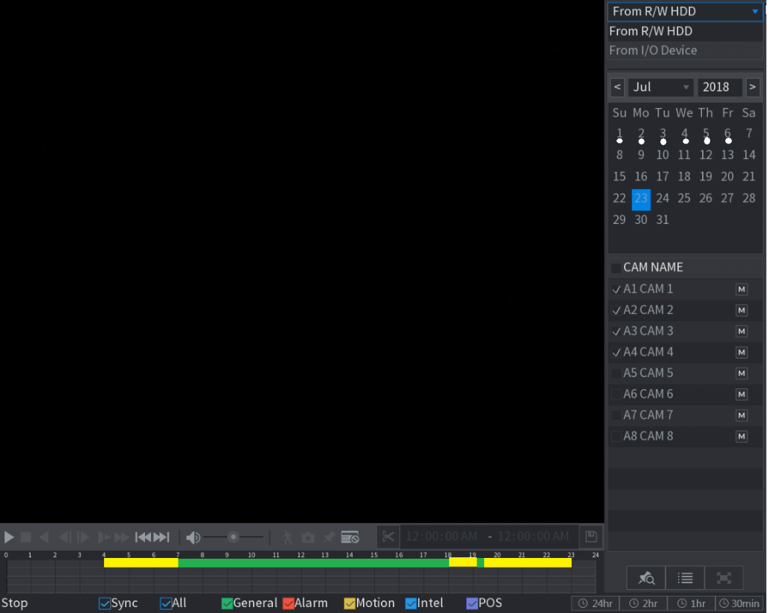

1. Select (check) the camera channels to search.

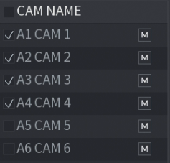

1. Click your mouse on the time bar to select the time to begin the playback. Time of the day is indicated using 0 – 24, which means “0” is equal to 12 morning and 24 means 12 evening/night. Camera channels with available recorded video will start to playback video while other channels with no recorded video will simply show black or blank screen. Hover the mouse on each icon to identify the function such as Play, Slow Playback, Fast Playback, Previous Day, Next Day etc…

