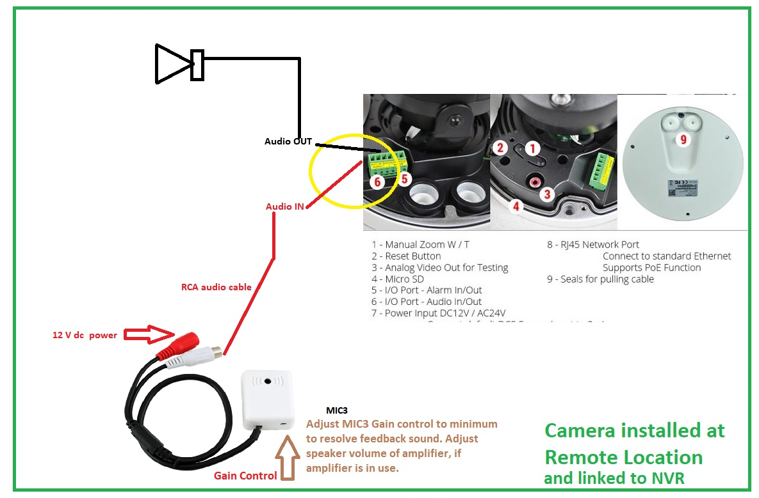

1. Connect a speaker to the IP camera using Audio OUT
2. Connect CCTV MIC3 to the IP camera using Audio IN
3. Adjust Mic gain control when you’re getting feedback sound or adjust amplifier volume control



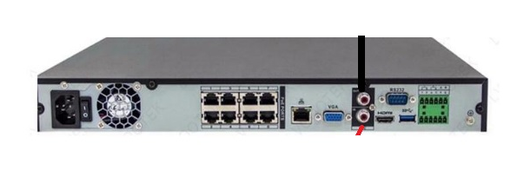

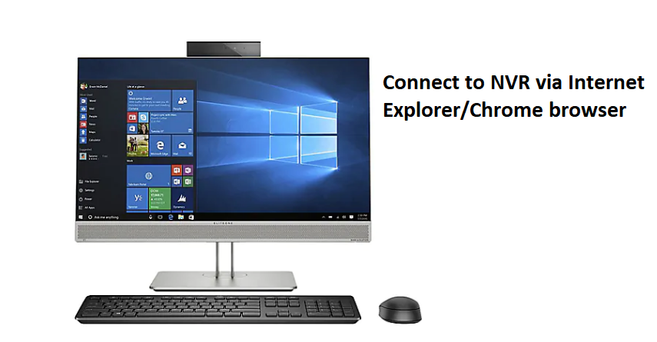

1. Run browser on PC or mobile app on a phone to connect to NVR IP address
2. Connect a mic on your PC with PC audio speaker connected to the computer.

At the Internet Explorer LIVE page, click the two-way audio icon

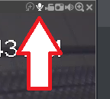

* You will be able to hear audio from a microphone attached to the IP camera, at the same time, you can speak at the microphone connected to your computer and the audio from your computer mic can be heard at the speaker connected to the IP camera.
* 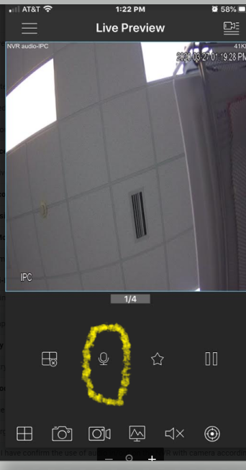

You can tap and hold this mic to speak and send audio to the IP camera speaker.