**Optiview VMS – Backup and Restore Device List**

The Import and Export utility within the Optiview VMS software allows the user to make a backup file for the devices listed within the Device List menu and later import/restore the backup file to a newly installed software or to a new workstation computer.

1. Select Devices from the Main menu.

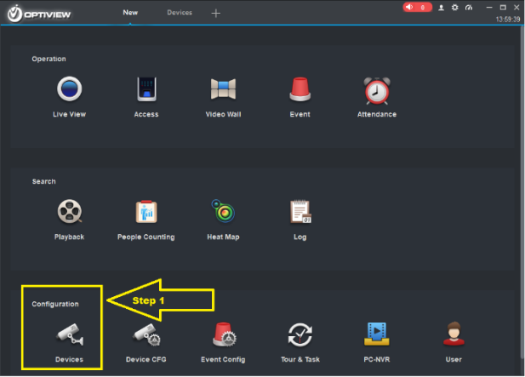

1. Select which devices needs to be backed up from the list.

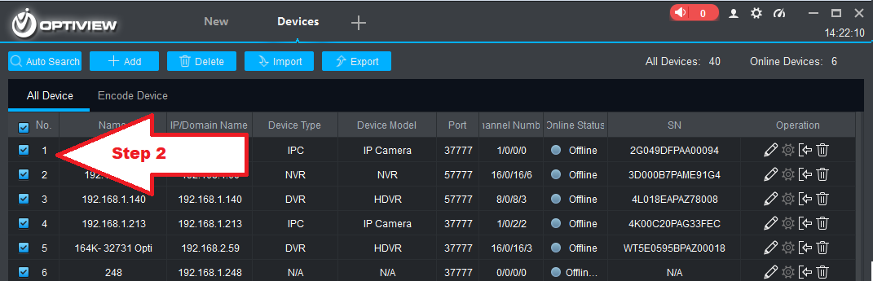

1. Click **Export** button to save the file on your preferred folder location such as USB drive. Select “Local Path” folder icon to the right to save backup file on your drive.

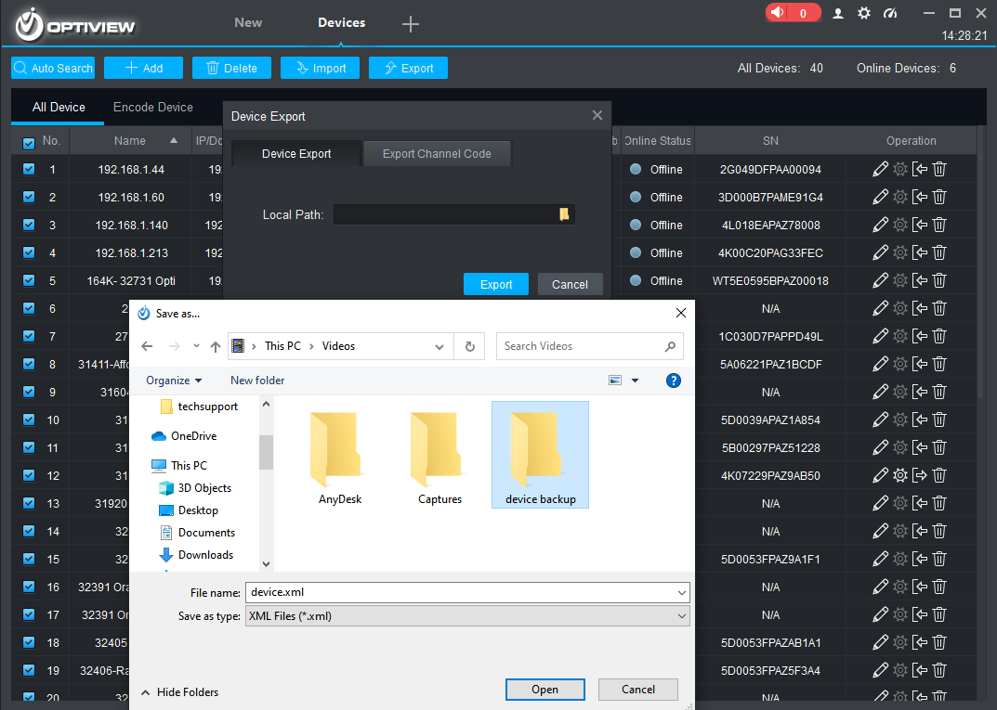 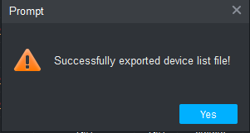

1. To restore list of devices to a newly installed Optiview VMS, follow the steps 1 and 2.
2. Click **Import** button to save the file on your preferred folder location such as USB drive. Select “Local Path” folder icon to the right to save backup file on your drive.

